# Cloud server

היום אנחנו משתמשים ב- thingSpeak. זה פלטפורמת ענן שמדברת עם ה- clients ב- http. הם מספקים libraries של קוד לשימוש ב- client-ים נפוצים.

* העלאת מידע ואחסונו בענן
* כלי ניתוח בסיסיים
* יכולת תגובה לתנאים מוגדרים מראש

המידע ב- thingSpeak מאוחסן ב- channel-ים. כאשר client מעלה data, הוא אומר לאיזה מה- channels הוא רוצה לשמור. בדרך כלל נחזיק channel לכל endpoint.

<https://thingspeak.com/>

email: [kalk.tal@gmail.com](mailto:kalk.tal@gmail.com)

password: p…

1. Select channel
2. Fields in our channel:

|  |  |  |
| --- | --- | --- |
| Soil moisture (raw units) | Reading of the moisture sensor |  |
| Wifi Signal (rssi) | Wifi signal strength |  |
| Sampling Time (ms) | How long it took to the signal to transmit |  |

# End point unit

## Endpoint battery

* עלות
* עמידה בתנאי סביבה
* Capacity
* מחיר
* זמינות

עלות: 15 שקלים

## Endpoint unit microcontroller

|  |  |  |
| --- | --- | --- |
| Chip | Esp32 model WRoom-32 | Espressif |
| Development board | Ttgo  Or  Lolin32  Both use WRoom-32 | Wemos |

יתרונות של המיקרו-קונטרולרים האלו:

* זולים
* ביצועים טובים
* Bluetooth, Wifi
* פרוטוקול תקשורת proprietary בשם ESPNow

עלות: 66 שקלים

## Endpoint Humidity sensor

Capacitive humidity sensor. תוצרת DFRobot. עלות: 10 שקלים.

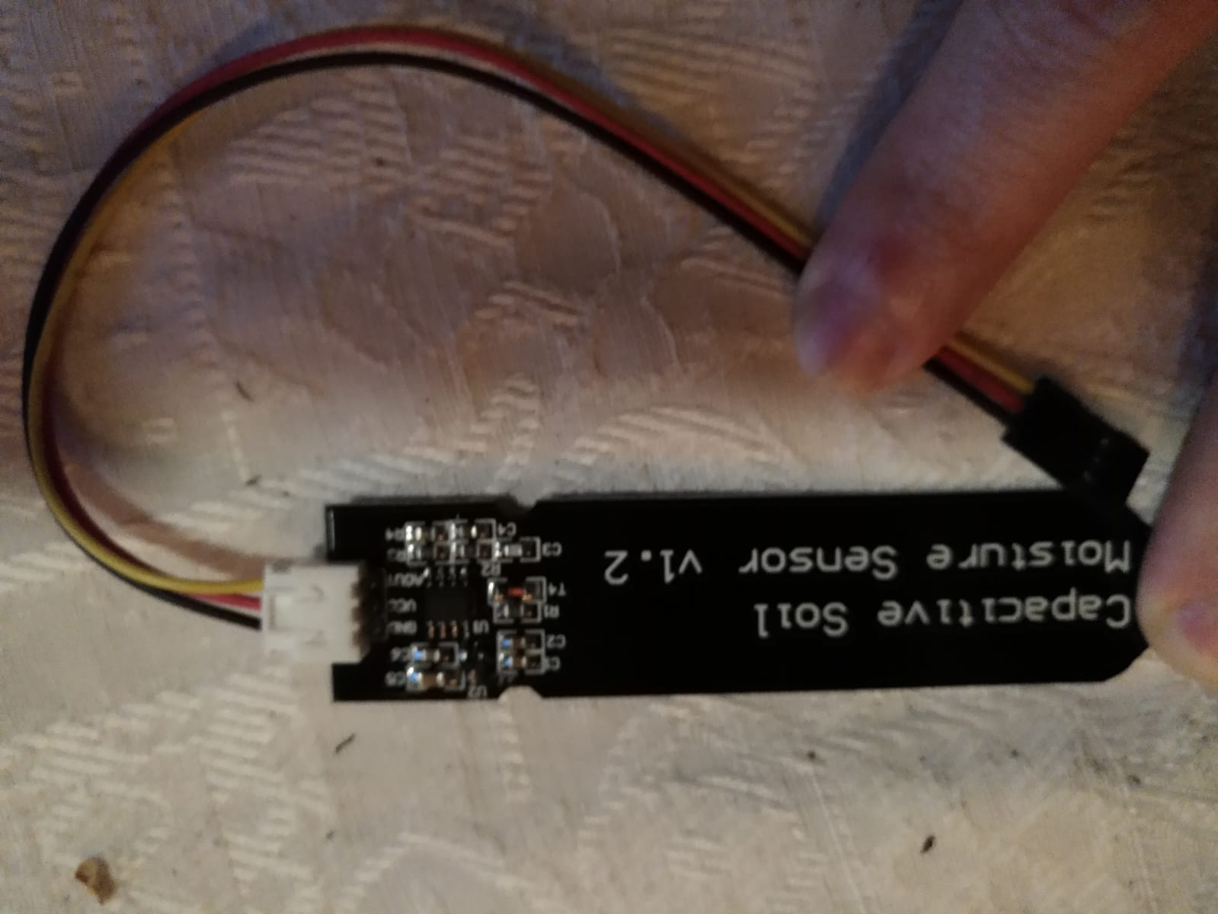

## Endpoint wiring

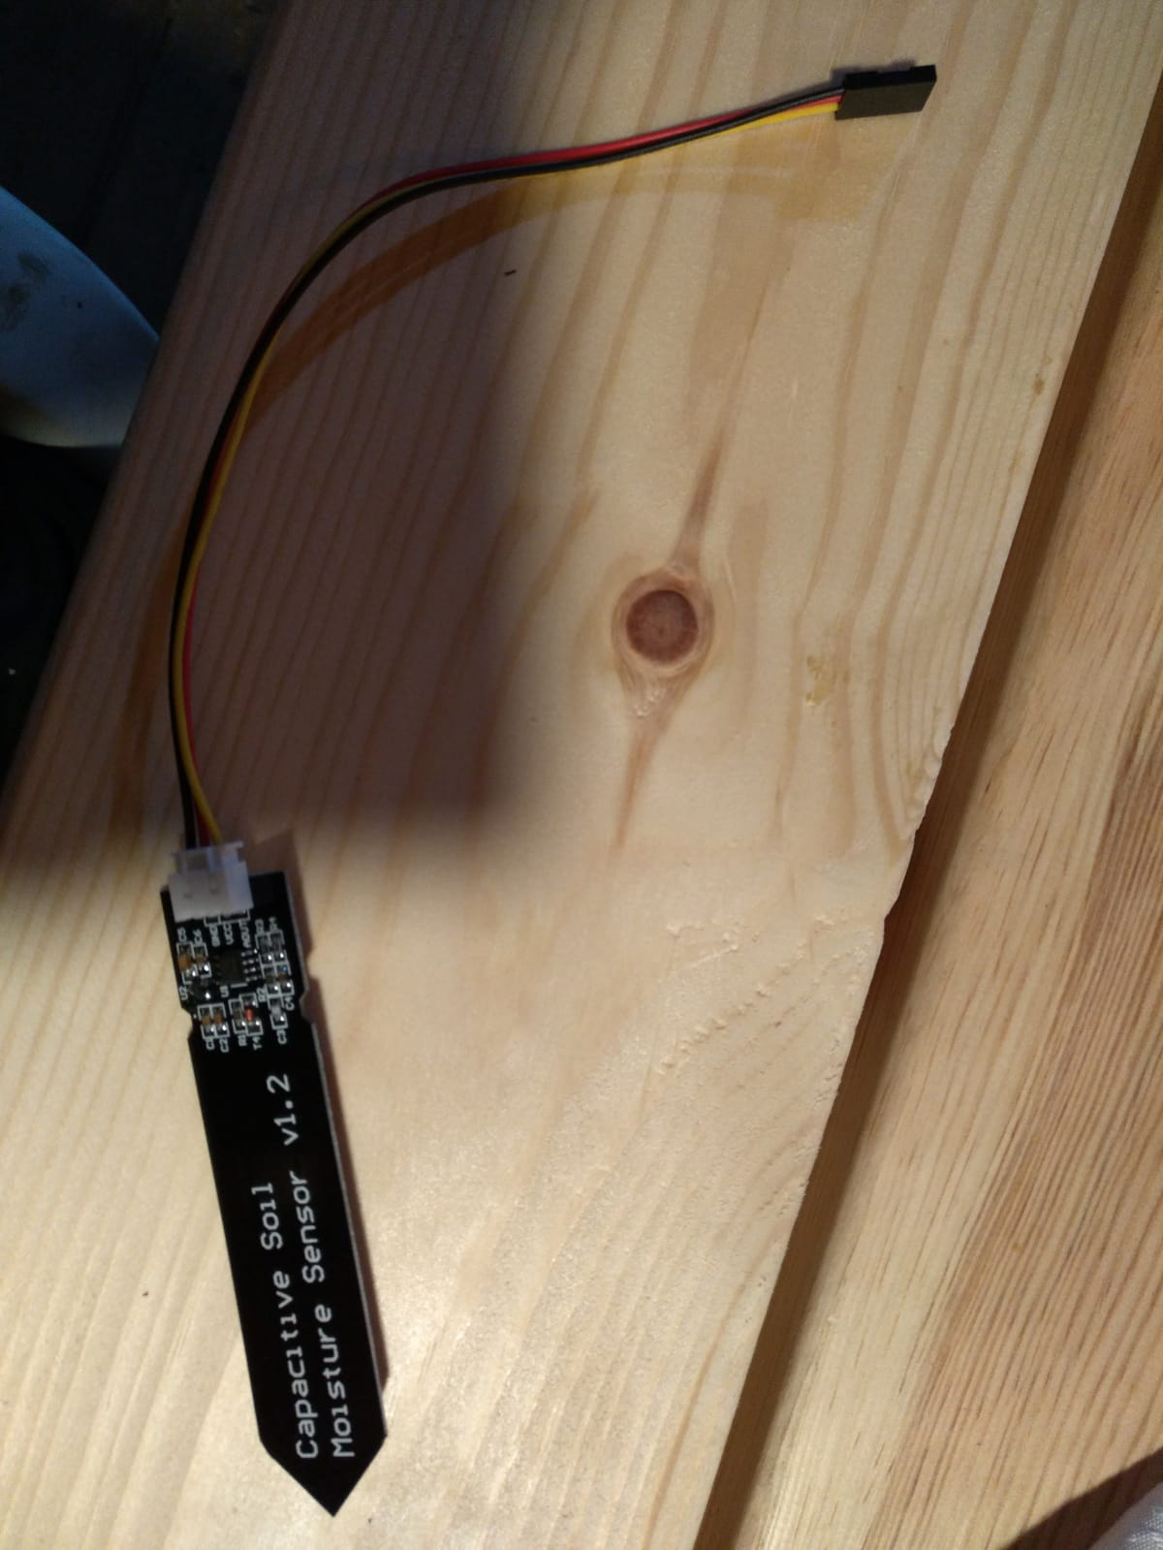

The blue areas indicate potting points, for waterproofing.

Potting of sensor:

We use a nylon bag filled with silicon.

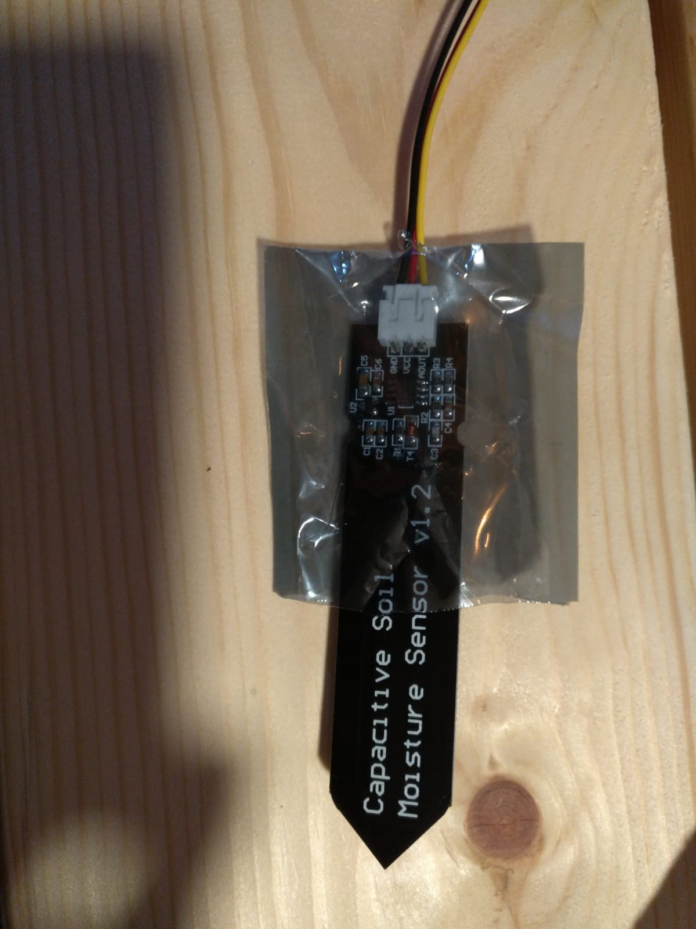

# Moisture sensor repeatability

Minimal achievable reading - 1450

|  |  |  |  |
| --- | --- | --- | --- |
| Sensor ID | Room temperature, no water | Room temperature, shallow water | Room temperature, deep water |
| Sensor disconnected | <100 | N/A |  |
| 1 | 3215 | 1635 | 1470 |
| 2 | 3237 | 1665 | 1525 |
| 3 | 3212 | 1675 | 1490 |
| 4 | 3211 | 1650 | 1490 |
| 5 | 3200 | 1640 | 1565 |

# Network topology

* The tap controller connects to the router through wifi as a client
* Opens an access point service to serve the endpoints
* Delivers messages from the endpoints to the cloud server

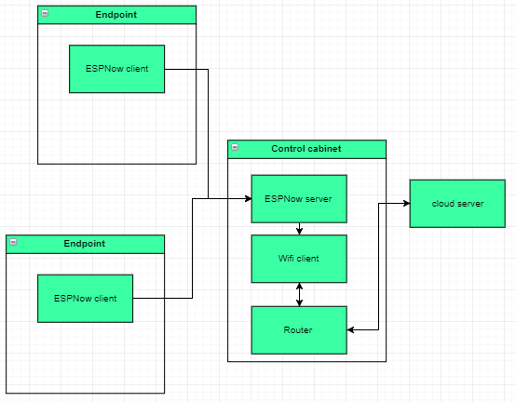

# Versions

## Endpoint version 0.0.1

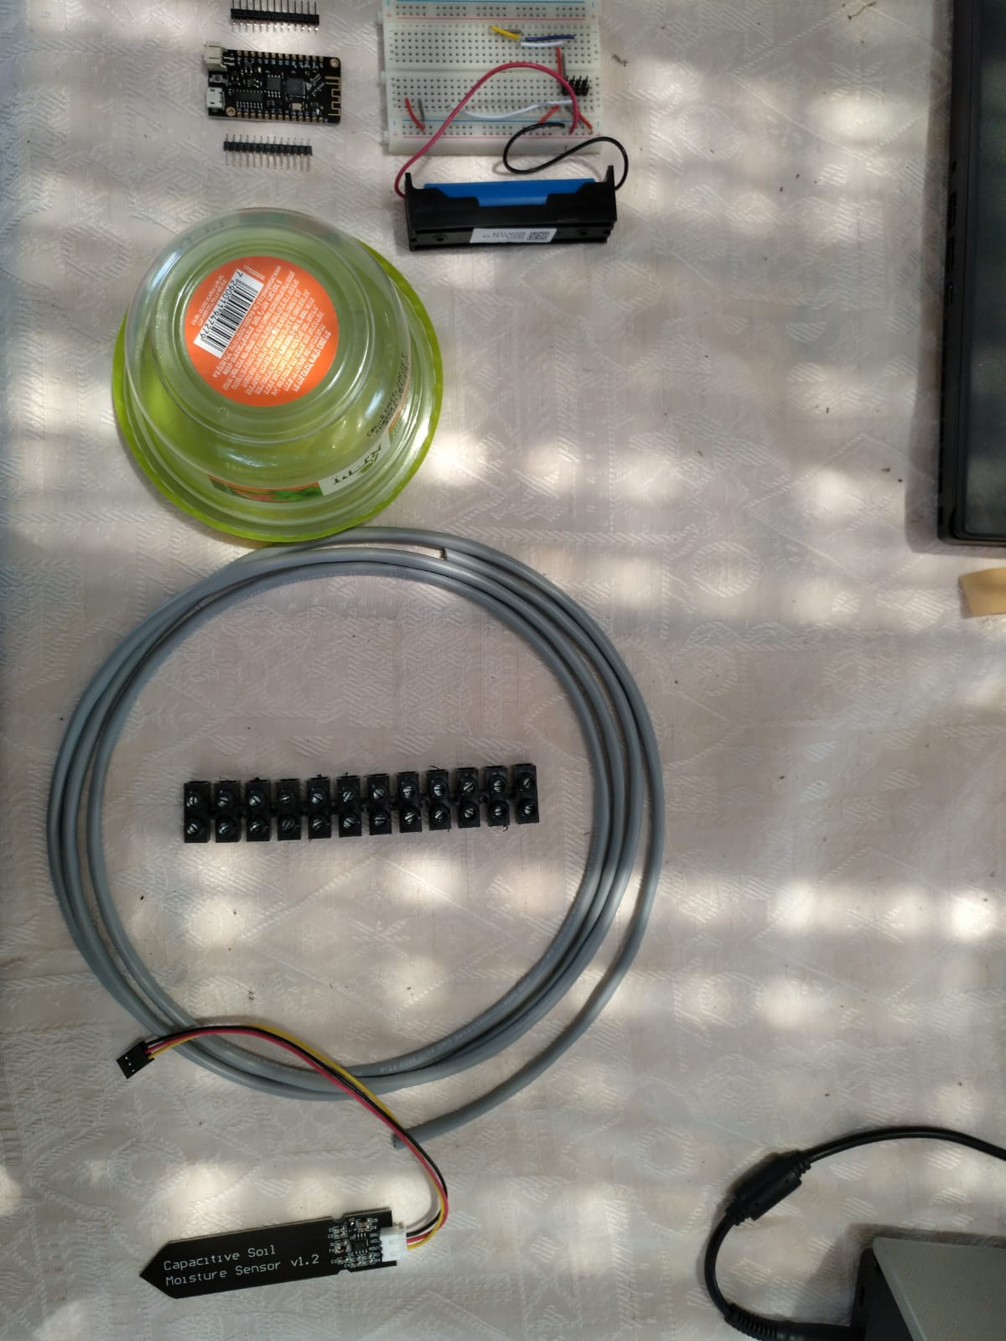

1. Cut the moisture sensor’s cables. Leave about 4 cm. Then connect them to the extension cord. It’s best to use shrinks when connecting the moisture sensor’s cable to the extension cord.

|  |  |
| --- | --- |
|  |  |

1. Insulate the sensor and its connection to the extension cord together using silicone

|  |  |  |
| --- | --- | --- |
|  |  |  |

1. The design is to connect the extension cable to the breadboard using screw terminals, but since we currently don’t have them, we will use the end of the sensor cable that we cut, as it has a connector to a breadboard header.
2. Shorten the Lolin’s JST battery cable

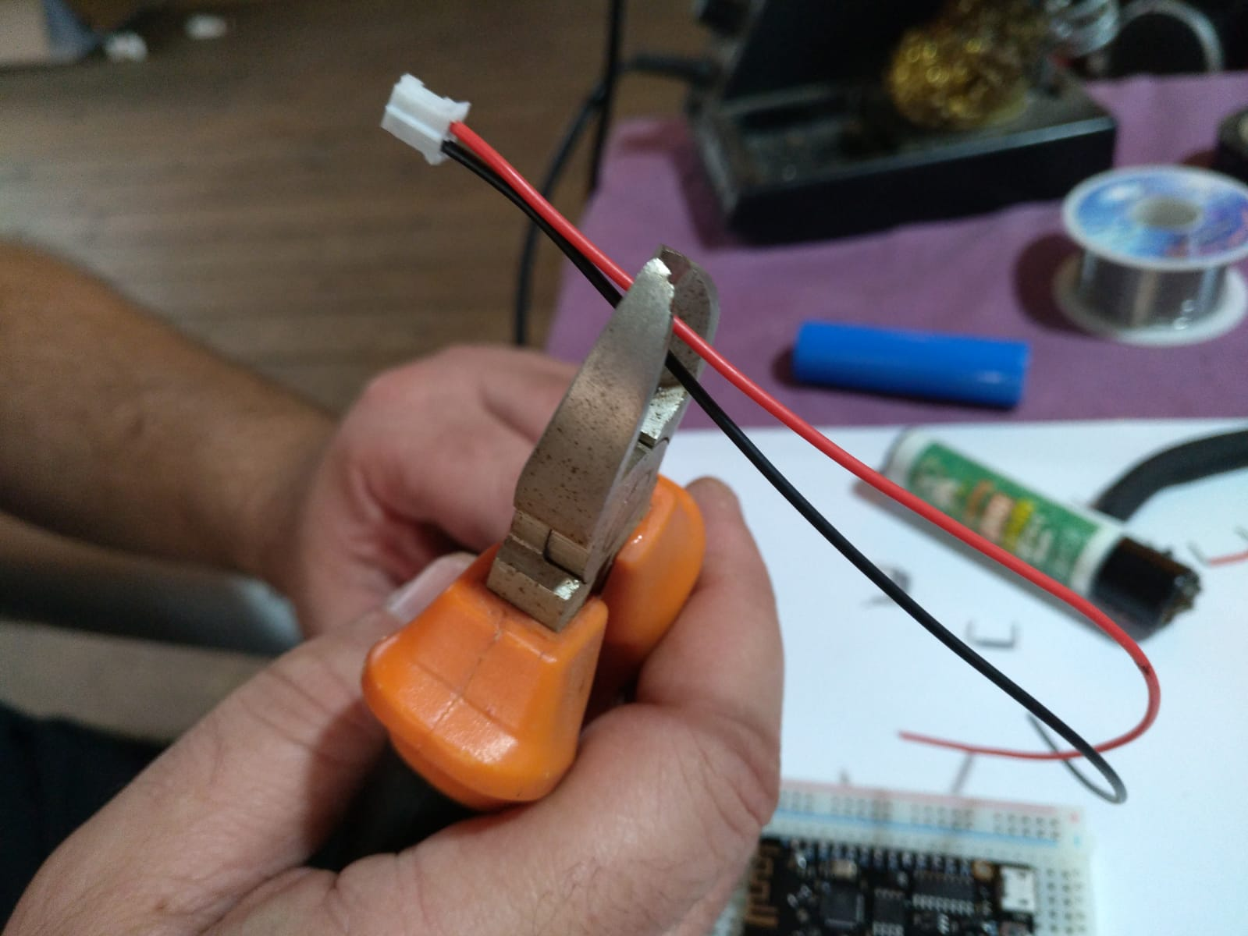

1. Solder the battery holder cables to the Lolin’s JST battery connector. (Red and black cables). Use shrinks to protect the solder.

|  |  |
| --- | --- |
|  |  |

1. Solder the Lolin’s headers to the Lolin board (soldering temp. $300℃$)

|  |  |
| --- | --- |
|  |  |

1. Before connecting the Lolin to the battery holder, make sure that the plus of the battery connects to the plus of the Lolin, not the other way around!!!

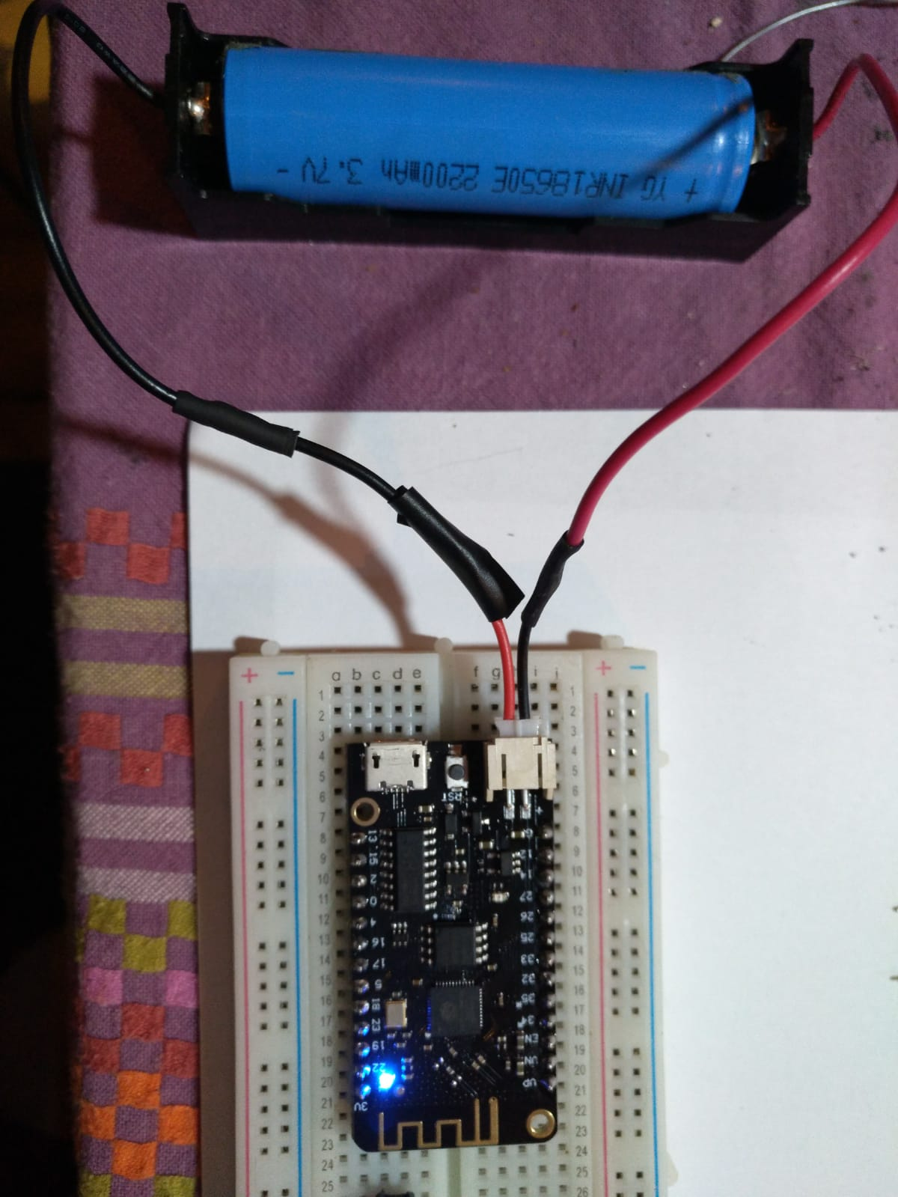

1. Connect the soldered Lolin to the breadboard such that the Lolin and it’s battery connector don’t stick out of the breadboard

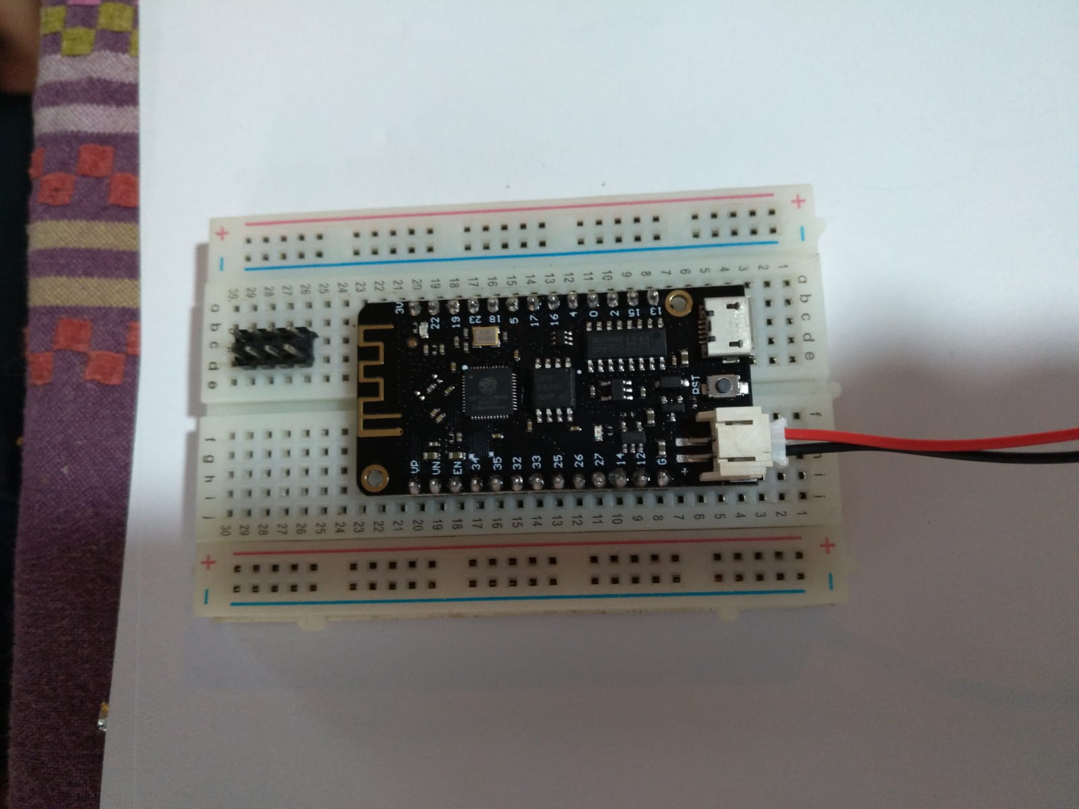

1. Using jumpers, connect the Lolin to the extension cable through the header using 3 pins:
   1. Ground.
   2. 3.3 Vcc. Pin 17
   3. Analog signal. Pin 33

|  |  |
| --- | --- |
|  |  |

The cables of the sensor:

1. Yellow – analog output signal
2. Black – gnd
3. Red – Vcc 3.3V
4. Place the battery in the battery holder
5. Place the battery holder and the breadboard in the plastic box

|  |  |  |
| --- | --- | --- |
|  |  |  |

1. Plant the sensor!

|  |  |  |
| --- | --- | --- |
|  |  |  |

# Passwords

|  |  |  |
| --- | --- | --- |
| Microsoft account | [Hydrosmart33@outlook.com](mailto:Hydrosmart33@outlook.com) | q1w2a1s2 |
| Github | HydroSmart | q1w2a1s2d3 |

# Adding collaborators to repository

1. Ask the new collaborator to create a GitHub account
2. Open [www.github.com](http://www.github.com)
3. Login is HydroSmart:q1w2a1s2d3
4. Open the repository
5. Click Settings on the top right
6. Click Collaborators
7. Add the collaborator, using his user name

# Set up a development computer

1. Install Git
2. Install Visual Studio Code
3. Ask the repository admin to send you a GitHub invitation
4. The invitation arrives in email. Approve it
5. Open Command Prompt (or PowerShell) and navigate to the folder where you want the repository
6. Copy and paste to Command Prompt or PowerShell the following line:

git clone https://github.com/HydroSmart/HydroSmart/

1. Open Visual Studio Code
2. Open the Command Pallete. View->command Palette… (or ctrl+shift+P)
3. Type Add folder to workspace, then select the HydroSmart folder